partA /misc

./yas sum.ys

./yis sum.yo

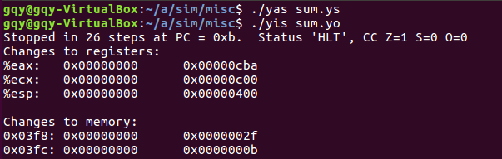

partA /misc

./yas rsum.ys

./yis rsum.yo

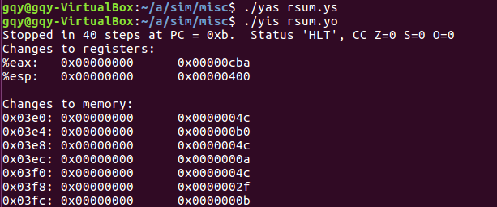

partA /misc

./yas copy.ys

./yis copy.yo

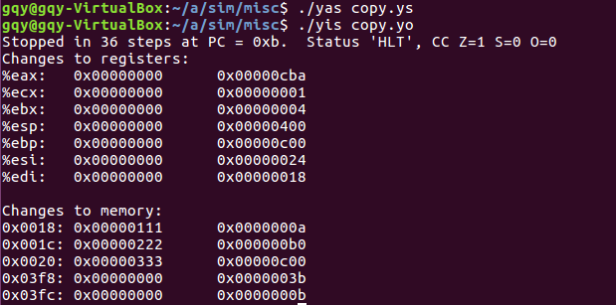

partB /seq

benchmark test

make VERSION=full

(cd ../y86-code; make testssim)

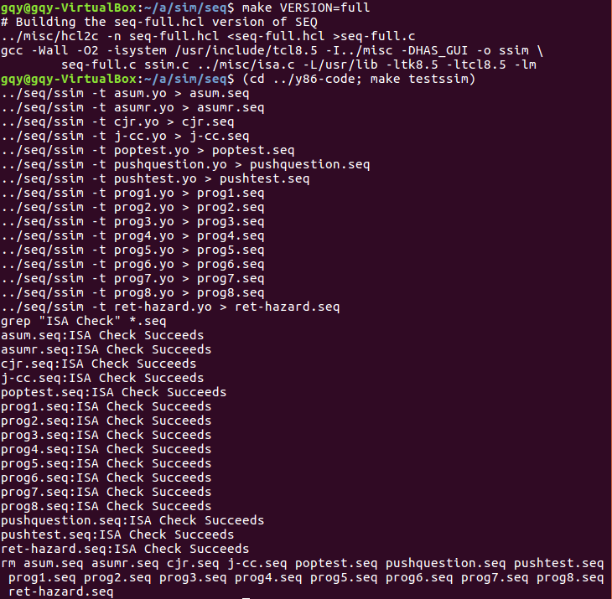

partB /seq

regression test

(cd ../ptest; make SIM=../seq/ssim)

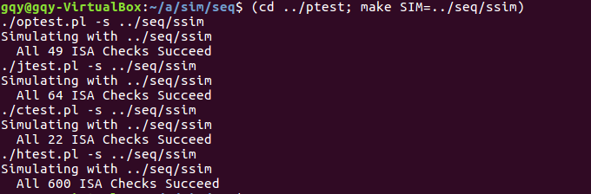

partB /seq

ptest for iaddl

(cd ../ptest; make SIM=../seq/ssim TFLAGS=-i)

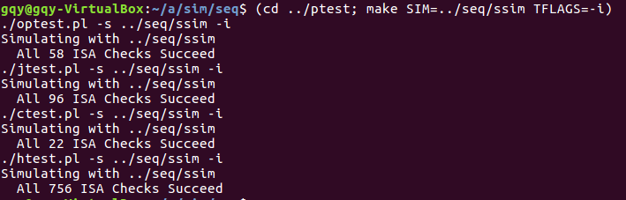

partB /seq

ptest for leave

(cd ../ptest; make SIM=../seq/ssim TFLAGS=-l)

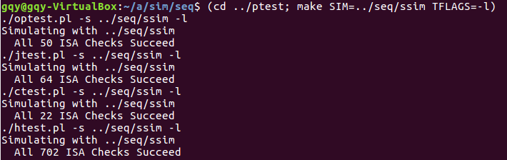

partB /seq

ptest for iaddl and leave

(cd ../ptest; make SIM=../seq/ssim TFLAGS=-il)

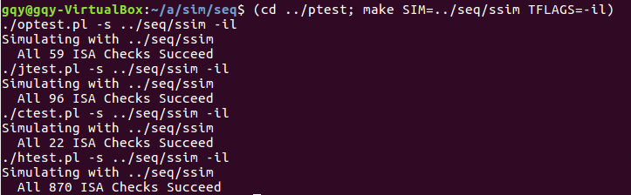

partC /pipe

make drivers

make psim VERSION=full

y86-code test

(cd ../y86-code; make testpsim)

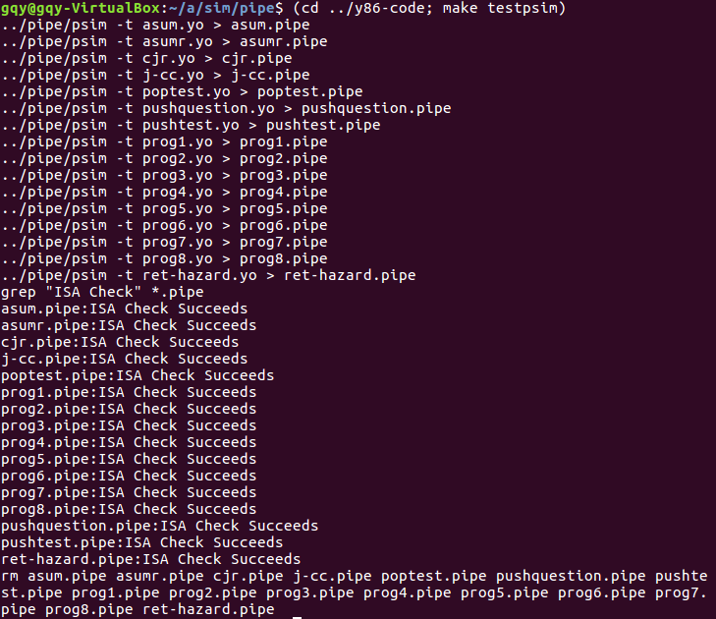

partC /pipe

ptest test

(cd ../ptest; make SIM=../pipe/psim TFLAGS=-i)

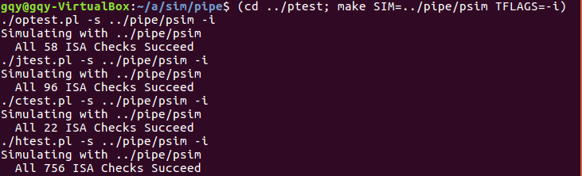

partC /pipe

correctness test

./correctness.pl

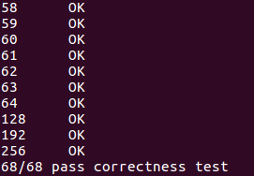

partC /pipe

CPE test

./benchmark.pl

